
Faculty of Engineering
Department of Computer Engineering
Course Code | ME105301 | Semester | 1
Course Code | ME105301 | Semester | Teaching & Learning Scheme (In Hours Per Semester )
Category | Core I |  | Classroom Instruction |  |  | Extended Learning |  | Total Hours | Total Credits
Category |  |  | L | T | P | TW | SL | HR | C
Course Name | Mathematical Foundation of Computer Science |  | 48 | 0 | 24 | 30 | 18 | 120 | 4

Course Objectives
- To develop a strong foundation in mathematical concepts required for computer science and engineering applications.
- To identify and solve problems related to graphs, networks, permutations, and combinatorial structures.
- To implement mathematical and statistical techniques using computational tools for simulation and data analysis.
- To enhance logical reasoning and analytical thinking required for advanced topics such as machine learning, data mining, and artificial intelligence.
- To prepare students for advanced studies and applications in areas like computer security, bioinformatics, distributed systems, and machine learning.
Prerequisite

- To have a strong understanding of school-level mathematics including algebra, functions, matrices, and basic calculus.
- To be familiar with logical reasoning, truth tables, and basic problem-solving using logical statements.
- To understand sets, subsets, relations, and functions, which are essential for discrete mathematics concepts.

Syllabus – Total Contact Hours -48 No Of Credits-3
Unit-1 Probability and Statistical Foundations | 7
Probability mass, density, and cumulative distribution functions,
Parametric families of distributions, Expected value, variance,
conditional expectation, Applications of the univariate and multivariate Central Limit Theorem, Probabilistic inequalities, Markov chains
Unit-2 Statistical Inference and Estimation | 7
Random samples, sampling distributions of estimators, Methods of Moments and Maximum Likelihood. | 7
Unit-3 Multivariate Statistics and Machine Learning | 8
Statistical inference, Introduction to multivariate statistical models: regression and classification problems, principal components analysis, The problem of over fitting model assessment.
Unit-4 Graph Theory and Combinatorics | 9
Graph Theory: Isomorphism, Planar graphs, graph coloring, Hamilton circuits and Euler cycles. Permutations and Combinations with and without
repetition. Specialized techniques to solve combinatorial enumeration problems

Uni-5 Computer Science Applications | 9
Computer science and engineering applications: Data mining, Network protocols, analysis of Web traffic, Computer security, Software engineering, Computer architecture, operating systems, distributed systems, Bioinformatics, Machine learning.
Unit-6 Trends | 5
Recent Trends in various distribution functions in mathematical field of
computer science for varying fields like bioinformatics, soft computing, and computer vision

Term Work Module 30 hours

Objective:
- To strengthen understanding of fundamental concepts in probability, statistics, graph theory, and combinatorics through practical exercises and assignments.
- To apply mathematical and statistical techniques to solve computational problems in a structured and logical manner.
- To develop the ability to analyze data using concepts such as expectation, variance, sampling, and estimation methods.
- To implement basic probability models, Markov chains, and statistical simulations using computational tools.

Term work-1 : Probability and Statistical Foundations( 5 hr)

1. Probability Distributions
Topics:
- Probability Mass Function (PMF)
- Probability Density Function (PDF)
- Cumulative Distribution Function (CDF)
Key distributions:
- Bernoulli
- Binomial
- Poisson

Term work 2 : Study of Distributions (5hr)

Write a brief note on each distribution including:
- Definition
- Probability function (PMF/PDF)
- Mean and Variance
- Real-world applications in computing
- Binomial Distribution
- Poisson Distribution
- Normal Distribution

Term Work:3 :Statistical inference (5hr)
- Regression and classification models
- Principal Component Analysis (PCA)
- Overfitting and model assessment

Term Work 4: Graph isomorphism (5hr)

- Planar graphs
- Graph coloring
- Hamilton circuits and Euler cycles
- Permutations and combinations (with and without repetition)
- Combinatorial enumeration techniques

Term work 5 : Topics Covered (5hr)
- Data mining
- Network protocols
- Web traffic analysis
- Computer security
- Software engineering
- Machine learning

Term work :6 : Recent trends in probability distribution functions (5hr)
- Applications in bioinformatics
- Soft computing techniques
- Computer vision applications
- Emerging statistical and machine learning models

Self-Learning Module 18 hours

Objective:
- To develop independent learning skills in mathematical and statistical concepts related to computer science.
- To understand the foundations of probability, statistics, graph theory, combinatorics, and machine learning.
- To apply mathematical techniques for solving real-world computing problems.
- To strengthen logical reasoning, analytical thinking, and problem-solving abilities.
- To explore applications of mathematical foundations in:
- To prepare students for advanced studies and industry-oriented applications in information technology
- To supplement classroom learning through self-study using online resources and simulation tools, focusing on understanding power system transients, travelling waves, lightning effects, surge protection, and insulation coordination in power systems.

Recommended Learning:
- Discrete Mathematics and Its Applications by Kenneth H. Rosen
- Introduction to Probability Models by Sheldon M. Ross
- Probability and Statistics for Engineers and Scientists by Ronald E. Walpole
- Pattern Recognition and Machine Learning by Christopher Bishop
- Graph Theory with Applications by J. A. Bondy and U. S. R. Murty

Recommended Courses:

Probability & Statistics Courses
- Probability and Statistics – NPTEL
- Introduction to Probability – Coursera
- Statistics and Probability – Khan Academy

Machine Learning & Data Science Courses
- Machine Learning Specialization – Coursera
- Machine Learning – NPTEL
- Data Science Courses – edX

Discrete Mathematics & Graph Theory Courses
- Discrete Mathematics – MIT OpenCourseWare
- Graph Theory – NPTEL
- Combinatorics and Graph Theory – Coursera

Programming & Tools Courses
- Python for Everybody – Coursera
- Python Programming – NPTEL
- MATLAB Onramp
- R Programming – Coursera

Advanced & Emerging Topics
- Artificial Intelligence – Coursera
- AI and Machine Learning – edX
- Computer Vision Basics – Coursera

Link:
SWAYAM Courses
Learning Resources

- Discrete Mathematics and Its Applications – Kenneth H. Rosen
- Introduction to Probability Models – Sheldon M. Ross
- Probability and Statistics for Engineers – Ronald E. Walpole
- Graph Theory with Applications – J. A. Bondy, U. S. R. Murty

Reference Books

- Kenneth H. Rosen – Discrete Mathematics and Its Applications
- Sheldon M. Ross – Introduction to Probability Models
- Ronald E. Walpole – Probability and Statistics for Engineers and Scientists
- C. L. Liu – Elements of Discrete Mathematics
- J. A. Bondy & U. S. R. Murty – Graph Theory with Applications

Teaching-Learning Process / Pedagogy

1. Overall Pedagogical Approach
- Theoretical explanation of mathematical concepts
- Step-by-step problem solving
- Computational implementation using software tools
- Real-world applications in computing domains

2. Teaching Methods

a) Chalk and Talk / Interactive Lectures
- Explanation of probability, statistics, graph theory, and combinatorics
- Step-by-step derivations and formula understanding
- Concept clarification with real-life analogies

b) ICT-Based Teaching (Digital Learning)
Use of tools like:
- Python
- MATLAB
- Jupyter Notebook
- WEKA

c) Problem-Solving Sessions
- Numerical exercises on:
  - Expectation and variance
  - Conditional probability
  - Statistical estimation
- Graph theory problem solving (Euler, Hamilton, coloring)
- Combinatorics practice sessions

d) Experiential / Activity-Based Learning
- Simulation of Central Limit Theorem
- Data analysis using real datasets
- Mini-projects in machine learning and statistics
- Case studies from real-world systems

e) Collaborative Learning
- Group assignments on statistical modeling
- Peer discussion of graph theory problems
- Seminar presentations on applications

f) Project-Based Learning (PBL)
Students develop mini-projects such as:
- Markov chain prediction models
- Network traffic analysis
- PCA-based dimensionality reduction
- Fraud detection systems

g) Self-Learning / Flipped Classroom
- Pre-study of topics before class
- Watching lectures from: NPTEL ,Coursera
- Classroom used for discussion and problem-solving

3. Learning Techniques Used
- Concept mapping (Probability → Statistics → ML)
- Visual learning (graphs, distributions, plots)
- Algorithmic thinking (step-by-step logic building)
- Simulation-based understanding
- Case-study approach

4. Expected Teaching Outcomes
After this pedagogy, students will be able to:
- Understand abstract mathematical concepts clearly
- Apply theory to computational problems
- Develop programming-based solutions
- Analyze data scientifically
- Connect mathematics with real-world computing systems

COURSE OUTCOME

CO No. | Course Outcome | Bloom’s Level
CO1 | Understand probability & distributions
CO2 | Apply statistical methods
CO3 | Analyze statistical models
CO4 | Apply graph & combinatorics

MAPPING WITH PROGRAM OUTCOME

CO No. | PO1 | PO2 | PO3 | PO4 | PO5 | PO6 | PO7 | PO8 | PO9 | PO10 | PO11 | PO12 | PSO1 | PSO2 | PSO3
CO1 | 3 | 2 | 1 | 2 | 2 | 1 | 1 | 1 | 1 | 1 | 1 | 2
CO2 | 3 | 3 | 2 | 2 | 3 | 1 | 1 | 1 | 2 | 1 | 1 | 2
CO3 | 3 | 3 | 2 | 3 | 3 | 1 | 1 | 1 | 2 | 2 | 1 | 3
CO4 | 3 | 3 | 3 | 2 | 3 | 1 | 1 | 1 | 2 | 2 | 1 | 2

COPO MAPPING JUSTIFICATION FOR MATHEMATICAL FOUNDATION OF COMPUTER SCIENCE

PO1(Engineering Knowledge): Apply the knowledge of basic sciences and engineering fundamentals to solve engineering problems.
PO2(Problem Analysis): Analyze the complex engineering problems and give solutions related to chemical & allied industries.
PO3(Design/ development of solutions): Identify the chemical engineering problems, design and formulate solutions to solve both industrial & social related problems.
PO4(Conduct investigations of complex problems): Design & conduct experiments, analyze and interpret the resulting data to solve Chemical Engineering problems.
PO5(Modern tool usage): Apply appropriate techniques, resources and modern engineering & IT tools for the design, modeling, simulation and analysis studies.
PO6(The engineer and society): Assess societal, health, safety, legal and cultural issues and their consequent responsibilities relevant to professional engineering practice.
PO7(Environment and sustainability): Understand the relationship between society, environment and work towards sustainable development.
PO8(Ethics): Understand their professional and ethical responsibility and enhance their commitment towards best engineering practices.
PO9(Individual and team work): Function effectively as a member or a leader in diverse teams, and be competent to carry out multidisciplinary tasks.
PO10(Communication): Communicate effectively in both verbal & non-verbal and able to comprehend & write effective reports.
PO11(Project management and finance): Understand the engineering and management principles to manage the multidisciplinary projects in whatsoever position they are employed.
PO12(Life-long learning): Recognize the need of self education and life-long learning process in order to keep abreast with the ongoing developments in the field of engineering.

Mapping With Sustainable Development Goals

 |  | SDG Mapping for - Mathematical Foundations of Computer Science (ME103101)
SDG No. and Title | Relevance to Course | Justification
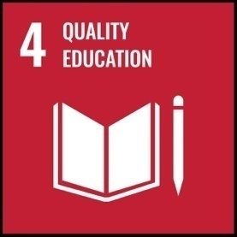 |  | It provides a strong theoretical foundation in probability, statistics, graph theory, and combinatorics essential for higher studies and research in computer science.

 |  | The course enhances employability and supports innovation, automation, and productivity in technology-driven sectors.
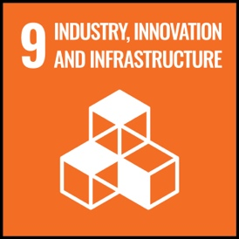 |  | The course contributes to technological innovation and development of intelligent and efficient computing infrastructure.
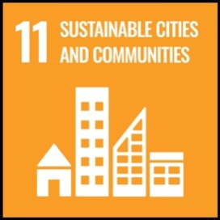 |  | The course supports efficient resource management, transportation systems, and digital communication networks
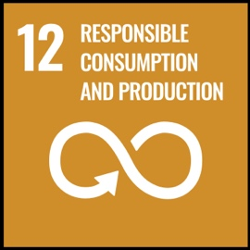
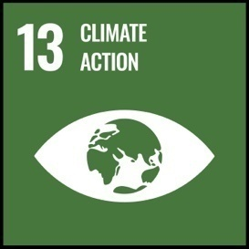
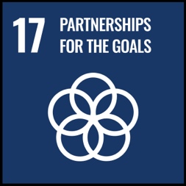 |  | The course promotes collaborative research and technology integration for sustainable development goals.

